Software Requirement Specifications
AI-Powered Personalized Product Platforms



Submitted by
Ayesha Khan (S23BINFT1M01014) 7th 1M
Submitted to
Ms.Sara Farid

Department of Information Technology
Faculty of Computing
The Islamia University of Bahawalpur

Revision History

Date | Description | Author | Comments

Document Approval
The following Software Requirements Specification has been accepted and approved by the following:
Signature |  | Printed Name | Title | Date

Supervised by
Ms.Sara Farid
Signature______ _____

Summery
This document specifies the requirements for an AI-driven recommendation system designed
specifically for e-commerce platforms. The system aims to solve the challenge of product discovery and personalization in online shopping by implementing machine learning algorithms that analyze user behavior and provide tailored product suggestions. This document outlines the need for an AI-enabled recommendation system for e-commerce websites as the proposed system. The problem that the system seeks to address is that of product discovery and personalization in the context of e-commerce, where the use of machine learning algorithms is utilized to analyze user behaviour in order to offer personalized product recommendations.

Table of Contents
1. Introduction 5
1.1. Purpose 6
1.1.1. Goals: 6
1.1.2. Objectives: 6
1.2. Scope 7
1.2.1. In-Scope 7
1.2.2. Out-of-Scope: 7
1.3. Product Perspective 7
1.3.1. Integration within the System: 7
1.4. User Characteristics 8
1.4.1. Admin 8
1.4.2. Data Entry Operators 9
1.4.3. Customers 9
1.4.4. System Developers/IT Support (Optional) 9
1.5. Similar apps and systems/Literature Review 10
1.5.1. Existing Apps and Systems 10
1.5.2. Literature Review 11
1.6. Proposed Technologies 12
1.6.1. Programming Language: 12
1.6.2. Frameworks and Libraries: 12
1.6.3. Database Management: 12
1.6.4. Front-End Technologies: 12
1.6.5. Data Handling and Caching: 12
1.6.6. Cloud Hosting and Deployment: 12
2. Requirements 13
2.1. Function Requirements 14
2.1.1. Product Recommendation Generation 14
2.1.2. Feedback Collection 15
2.1.3. Admin Management Panel 15
2.1.4. Real-Time Recommendations 16
2.2. Non-Functional Requirements 16
2.2.1. Performance Requirements 16
2.2.2. Availability 16
2.2.4. Usability Requirements 17
2.2.5. Maintainability 17
2.2.6. Compatibility 17
2.2.7. Data Integrity and Accuracy 17
2.2.7. Backup and Recovery 18
2.2.8. Environmental Requirements 18
3. Use Cases and Flow of Processes 18
3.1. System User 20
3.2. Admin 21
3.3. Client 22
3.4. Manager 23
4. References 25

Introduction
The e-commerce industry has experienced unprecedented growth, with the global market expected to reach $8.1 trillion by 2026. In this digital marketplace, personalization has become crucial for business success. This AI-Powered Product Recommendation System is designed to revolutionize how online retailers connect products with customers. The system leverages advanced machine learning algorithms including collaborative filtering , content-based filtering , and hybrid approaches to analyze user behavior patterns and provide personalized product suggestions in real-time.
The system will be particularly beneficial for small to medium-sized e-commerce businesses that need cost-effective solutions to compete with larger platforms. It's designed to process user interactions, including browsing patterns, purchase history, and product preferences, to generate accurate and relevant recommendations. The core modules include a user behavior tracking system, an AI recommendation engine, and a feedback collection mechanism, all integrated through a robust API framework .
This solution aims to serve various e-commerce platforms that typically handle thousands of daily users and manage product catalogs ranging from hundreds to millions of items. The system is built using open-source technologies like [Python]), TensorFlow , and PostgreSQL , making it both scalable and cost-effective while maintaining high performance standards with response times under 2 seconds and 99.9% uptime reliability.

Purpose
- Clearly define the goals and objectives of Project

Goals:
  - To enhance user experience by providing personalized product recommendations.
  - To increase customer engagement and conversion rates on e-commerce platforms.
  - To simplify product discovery for users through intelligent suggestions.

Objectives:
- Develop a recommendation engine that leverages machine learning algorithms to analyze user behavior and preferences.
- Build a system that integrates seamlessly with existing e-commerce platforms via APIs.
- Offer a scalable, cost-effective solution for small and medium-sized businesses to compete with larger platforms.
- Ensure the platform is reliable, secure, and capable of handling large datasets and high traffic efficiently.

Scope
    - In-Scope:
- Development of a recommendation engine using machine learning techniques like collaborative filtering, content-based filtering, and hybrid approaches.
- Implementation of a user behavior tracking system to analyze browsing patterns, purchase history, and preferences.
- Integration of an API framework to allow the recommendation engine to interact with e-commerce platforms.
- Design and implementation of an admin interface for managing recommendation settings and system analytics.
- Real-time generation of personalized product recommendations based on user activity.
- Collection of feedback from users to improve recommendations over time.

Out-of-Scope:
- Payment gateway integration or handling transactions.
- Inventory management or stock updates for e-commerce platforms.
- Development of a full-fledged e-commerce platform (the system will work as a module for existing platforms).
- Marketing or promotional tools like email campaigns or push notifications.
- Integration with platforms beyond the scope of standard e-commerce frameworks (e.g., social media apps).

Product Perspective
The AI-Powered Personalized Product Platform is designed to function as an independent module that integrates seamlessly into existing e-commerce systems. It will operate as a middleware solution, connecting user interfaces (front-end) with back-end databases to provide intelligent product recommendations.

Integration within the System:
- User Interaction (Front-End):
- The module will process user input (e.g., browsing history, clicks, searches) from the website or mobile application.
- Recommendations will be displayed dynamically on product pages, search results, or personalized dashboards.

- Back-End Connectivity:
- The module will fetch product data (e.g., descriptions, prices, categories) from the platform's existing product database.
- User data (e.g., purchase history, preferences) will be analyzed through the AI engine to generate recommendations.

- Recommendation Engine:
- The AI module acts as the core engine, using collaborative filtering, content-based filtering, and hybrid models to generate recommendations.
- A feedback loop will allow continuous learning and refinement of suggestions.

- APIs:
- The module will provide APIs for smooth communication between the recommendation engine and the e-commerce platform.
- These APIs will ensure compatibility with various platforms, enabling easy deployment across different systems.
- Scalability and Adaptability:
- The module is designed to handle varying product catalog sizes and user loads, making it suitable for small to medium-sized businesses.
- Open-source technologies like Python, TensorFlow, and SqlLite ensure cost-effectiveness while allowing customization as needed.

User Characteristics
Users such as admins, data entry operators, customers or other human roles that interact with system.

Admin
- Role:
- Oversee the overall functioning of the recommendation system.
- Manage user accounts, product data, and system settings.
- Responsibilities:
- Approve new user registrations and permissions.
- Monitor and evaluate the performance of recommendations.
- Troubleshoot and resolve system issues.
- Technical Expertise:
- Moderate to advanced technical skills.
- Familiarity with basic system operations and analytics tools.

Data Entry Operators
- Role:
- Input and update product-related data into the system.
- Ensure that product catalogs are accurate and up to date.

- Responsibilities:
- Add or modify product descriptions, images, categories, and prices.
- Verify that data complies with the system's requirements.

- Technical Expertise:
- Basic computer skills.
- Familiarity with the e-commerce platform's data management interface.

Customers
- Role:
- Browse the e-commerce platform, interact with the product recommendations, and make purchases.
- Responsibilities:
- Use the system to search for and discover products.
- Provide feedback on recommendations (e.g., liking or disliking suggestions).
- Technical Expertise:
- Minimal technical knowledge; primarily require an intuitive and user-friendly interface.
- Experience with basic online shopping platforms.

System Developers/IT Support (Optional)
- Role:
- Maintain and update the system infrastructure, including AI models and APIs.

- Responsibilities:
- Ensure system reliability, security, and scalability.
- Implement new features or updates as required.

- Technical Expertise:
- Advanced technical knowledge in programming, machine learning, and database management.

Similar apps and systems/Literature Review

Existing Apps and Systems
      - Amazon Recommendation Engine
  - Features:
    - Uses collaborative filtering and deep learning algorithms to analyze user behavior.
    - Provides personalized product recommendations in real-time.
    - Supports cross-selling and upselling strategies by suggesting complementary products.
  - Shortcomings:
    - High computational requirements make it unsuitable for small businesses.
    - The system lacks transparency regarding recommendation logic.
      - Netflix Recommendation System
- Features:
- Focuses on content-based filtering and collaborative filtering to
- recommend movies and shows.
- Provides a personalized homepage with suggestions based on user ratings and viewing history.
- Continuous improvement using user feedback.
- Shortcomings:
- Designed specifically for media content, limiting its adaptability to e-commerce platforms.
- Struggles with recommending niche or less popular items.
      - Shopify Product Recommendations
- Features:
- Built-in recommendation engine for Shopify e-commerce stores.
- Suggests products based on sales history and browsing behavior.
- Easy to integrate for small and medium-sized businesses.
- Shortcomings:
- Limited customization options for complex recommendation strategies.
- Cannot handle large datasets effectively.
      - Ebay Personalized Search and Recommendations
- Features:
- Combines user preferences with marketplace trends for tailored recommendations.
- Real-time search optimization to enhance user engagement.
- Shortcomings:
- Recommendations can sometimes focus too heavily on past purchases, ignoring evolving interests.
- Less effective for new users with little or no interaction history.

Literature Review
- "Personalized Recommendation Systems: Current Trends and Challenges" by J. Smith and K. Brown (2023)
  - Discusses the importance of hybrid recommendation systems that combine collaborative and content-based filtering.
  - Identifies scalability and cold-start problems as key challenges.
- "AI-Driven E-Commerce Solutions: A Survey" by P. Johnson et al. (2022)
- Explores the role of AI in enhancing user experience through personalization.
- Highlights the cost-effectiveness of open-source solutions for small businesses.

- "Enhancing Online Shopping Experiences with Recommender Systems" by A. Lee (2021)
- Focuses on the role of real-time data analysis in improving recommendation accuracy.
- Emphasizes the importance of feedback loops for system refinement.

Proposed Technologies

Programming Language:
- Python
- Primary programming language for implementing machine learning algorithms and backend development.

Frameworks and Libraries:
- Django
- For building a web-based API to serve recommendations and manage system operations.
- Scikit-learn
- For implementing machine learning models like collaborative and content-based filtering.
- TensorFlow/Keras
- For developing and training advanced machine learning models, including hybrid recommendation engines.
- Pandas and NumPy
- For efficient data manipulation, preprocessing, and analysis.

Database Management:
- MySQL/SqlLite
- For storing structured data, such as user profiles, product details, and interaction histories.

Front-End Technologies:
- HTML5, CSS3, JavaScript
- For structuring, styling, and adding interactivity to the e-commerce platform.

Data Handling and Caching:
- Redis
- For caching real-time recommendations to ensure faster response times.

Cloud Hosting and Deployment:
- AWS Free Tier or Heroku Free Tier
- For hosting and deploying the system to ensure scalability and accessibility.

Containerization:
- Docker
- To containerize the application for seamless deployment across multiple environments.

Version Control:
- Git/GitHub
  - For version control and collaborative development.

Requirements
The AI-Powered Personalized Product Recommendation System will serve to provide personalized product suggestions for users based on their behavior and preferences. The system will consist of several core functionalities, including data collection, recommendation generation, and real-time updates. First, the system will collect and process data from user interactions, such as product views, clicks, and past purchases. This data will be used by the recommendation engine to identify patterns and generate personalized product suggestions. The system will offer two types of recommendation models: Collaborative Filtering and Content-Based Filtering. The Collaborative Filtering model will suggest products that other users, with similar behaviors, have interacted with, while the Content-Based Filtering model will recommend products similar to those the user has previously shown interest in, based on attributes such as category, brand, or price.
Once these recommendations are generated, they will be delivered to the front-end of the e-commerce platform in real-time. The system will use an API to integrate seamlessly with the e-commerce site, ensuring that recommendations are up-to-date and relevant based on current user interactions. Additionally, users will be able to provide feedback on the recommendations, which will help the system continuously improve by adjusting the model based on user preferences and ratings.
The platform will include an administrative interface where an admin can manage system settings, monitor performance, and adjust parameters related to recommendation generation. The system will also include robust data tracking mechanisms to analyze user engagement and performance metrics for the recommendations, allowing for future optimizations.
To ensure the system remains scalable and cost-effective, it will be built using open-source technologies, with a focus on utilizing Python for the back-end and Django framework using HTML CSS & Java Script for the front-end, offering a flexible solution suitable for small to medium-sized e-commerce businesses. The use of cloud hosting services such as AWS or Heroku will ensure easy deployment and scalability.

2.1. Function Requirements
- User Sign Up
- Name: Ayesha32304
- Purpose: The sign-up process allows a new user to create an account and gain access to the e-commerce platform, enabling personalized recommendations.
- User(s): Customer
- Input:
- Name: The user’s actual name (as per ID card).
- Email: A valid email address for communication and notifications.
- Password: A password for account security (must be at least 8 characters, including a number).
- Phone Number: A working phone number for contact (e.g., for WhatsApp).
- Profile Picture: A recent photo of the user for identification purposes.
- Output:
- A new user profile is created, allowing the user to log in and access personalized product recommendations.

2.1.1. Product Recommendation Generation
- Name: Ayesha32304
- Purpose: The recommendation engine will generate personalized product suggestions for users based on their previous interactions (views, clicks, purchases).
- User(s): Customer
- Input:
- User Data: Information such as browsing history, past purchases, and clicks.
- User Preferences: Preferences such as favorite categories, brands, or price ranges.

- Output:
- A list of recommended products tailored to the user’s preferences and past behavior, delivered in real-time.

2.1.2. Feedback Collection
- Name: Ayesha32304
- Purpose: To collect user feedback on product recommendations, enabling continuous system improvement and learning.
- User(s): Customer
- Input:
- Rating: Thumbs up/thumbs down or star ratings (1-5) for the recommended products.
- Comments: Optional feedback on why the product was liked or disliked.
- Output:
- The feedback is stored in the system and used to improve future recommendations by adjusting the recommendation model.

2.1.3. Admin Management Panel
- Name: Ayesha32304
- Purpose: The admin will be able to manage user accounts, track system performance, and fine-tune recommendation algorithms.
- User(s): Admin
- Input:
- User Data: Access to all user profiles for managing accounts (create, delete, block).
- System Settings: Parameters for adjusting the recommendation engine, viewing analytics, and monitoring feedback.
- Output:
- Admin can perform necessary actions on user accounts and adjust system settings to optimize the recommendation model.

2.1.4. Real-Time Recommendations
- Name: Ayesha32304
- Purpose: To update product recommendations dynamically based on the user’s current browsing activity.
- User(s): Customer
- Input:
- Real-Time Interaction Data: Data about user actions, including clicks and searches.
- Output:
- Updated product recommendations are displayed to the user in real-time based on their interactions.

2.2. Non-Functional Requirements
Non-functional requirements describe the system’s overall attributes and performance criteria. These requirements ensure that the system meets the necessary standards for performance, reliability, security, and scalability. Below are the key non-functional requirements for the AI-Powered Personalized Product Recommendation System:

2.2.1. Performance Requirements
- Response Time: The system should provide personalized product recommendations within 2 seconds after the user interacts with the platform (e.g., clicks or searches for a product).
- Throughput: The system should be capable of handling at least 1000 concurrent users without performance degradation or delays in generating recommendations.
- Scalability: The system must be scalable to handle a growing number of users and product catalogs, supporting the addition of new products and users without significant reconfiguration or downtime.

2.2.2. Availability
- Uptime: The system should be available 99.9% of the time, ensuring high availability and minimal downtime. Maintenance windows should be scheduled in advance and occur during off-peak hours.
- Redundancy: To ensure high availability, the system should be deployed in a redundant setup with load balancing, failover mechanisms, and backups to prevent service interruptions.

2.2.3. Security Requirements
- Data Encryption: All sensitive data, including user information and transaction data, must be encrypted using industry-standard encryption techniques (e.g., AES-256) both in transit (using HTTPS) and at rest (using secure database encryption methods).
- Authentication and Authorization: User authentication should be done via secure methods such A built-in Django module (django.contrib.auth) that handles user authentication, including login, logout, password management, and permissions to ensure only authorized access. Users should have access only to the data and actions permitted for their role (e.g., customers should not have admin privileges).
- Data Privacy: The system must comply with relevant data protection regulations (e.g., GDPR, CCPA) to ensure user data privacy and user consent mechanisms for data collection and processing.

2.2.4. Usability Requirements
- User Interface: The system should have an intuitive and responsive user interface that is easy for non-technical users to navigate. The UI should be simple, clean, and optimized for both desktop and mobile devices.
- Accessibility: The platform should meet the WCAG 2.1 (Web Content Accessibility Guidelines) to ensure that users with disabilities (e.g., vision impairment) can also access the site and interact with recommendations.

2.2.5. Maintainability
- Modular Design: The system should be designed in a modular manner, making it easy to add or remove features (such as adding new recommendation algorithms) without significant refactoring or disruption.
- Documentation: Detailed technical documentation, including code comments and API documentation, should be provided to support future maintenance and updates.
- Error Logging and Monitoring: The system should include robust logging and monitoring capabilities, which help detect and resolve issues quickly. Logs should capture errors, performance metrics, and user activities that could be useful for debugging.

2.2.6. Compatibility
- Cross-Browser Compatibility: The recommendation system should work seamlessly across major browsers (e.g., Chrome, Firefox, Safari, Edge).
- Operating System Compatibility: The system should be compatible with popular operating systems like Windows, macOS, and Linux for both development and deployment environments.

2.2.7. Data Integrity and Accuracy
- Data Accuracy: The recommendation engine must ensure that the product suggestions are relevant and based on accurate, up-to-date user data.
- Consistency: The system should maintain data consistency, ensuring that product recommendations reflect the most recent user behavior and product information, even across distributed databases.

2.2.7. Backup and Recovery
- Automated Backups: The system should automatically back up data at regular intervals, ensuring that no data is lost in case of failure.
- Disaster Recovery: The system should have a disaster recovery plan in place, with procedures for restoring operations within a specified recovery time objective (RTO) and recovery point objective (RPO).

2.2.8. Environmental Requirements
- Hosting: The system will be hosted on cloud services (AWS or Heroku), providing scalability, cost-efficiency, and a flexible environment for deployment.
- Resource Consumption: The system should be optimized to minimize resource consumption, including CPU, memory, and network bandwidth, especially during high traffic periods.

Use Cases and Flow of Processes
Use cases are the formal representation of process flow defined by functional requirements. Authors should provide a flow of events in this. There should be system level use case which is directly influenced to project functions with their user(s) (called actor(s)) which are described in requirements chapters
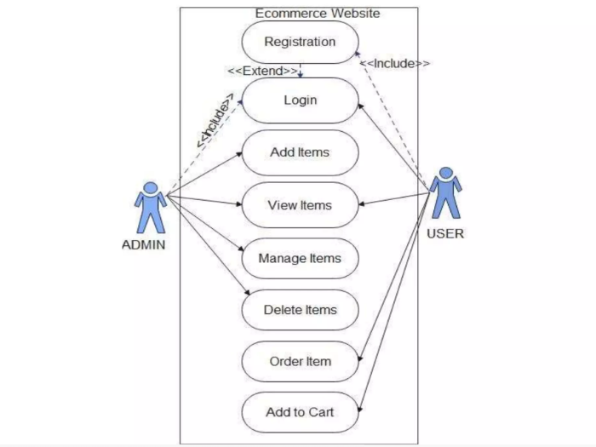
Figure 3.0 (Use Cases)

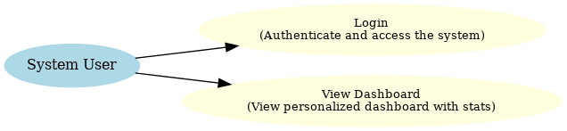
Figure 3.1 (System User)

3.1. System User
ID | UC001
Name | View Dashboard
Description | The system user can view their personalized dashboard with relevant data.
Requirement(s) | FR001
Actor(s) | System User
Precondition | User must be logged in.
Post condition | Dashboard is displayed with updated information.
Basic Flow | Basic Flow  - Actor logs into the system.  - System retrieves dashboard data.  - Check the following data fields:  1.1. Notifications  1.2. Recent activity  1.3. Quick links  - Format the data for user display.  - Display the dashboard to the user.  Alternative Flow  1. Actor refreshes the dashboard manually.  2. System retrieves and updates the dashboard in real-time.  Exceptions  1. Dashboard data cannot be retrieved due to a server error.  2. User session expires before the dashboard is displayed.
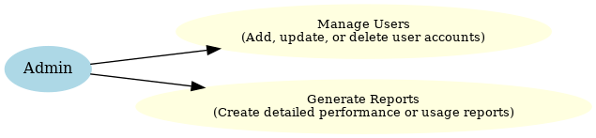 Figure 3.2 (Admin)

3.2. Admin
ID | UC002
Name | Manage Users
Description | Admin can add, edit, delete, or approve users.
Requirement(s) | FR002
Actor(s) | Admin
Precondition | Admin must be logged in.
Post condition | Changes to user accounts are saved successfully.
Basic Flow | Basic Flow  - Admin navigates to the user management module.  - Admin selects the desired operation (add, edit, delete).  - Enter the following user details:  1.1. Name  1.2. Email  1.3. Role (Admin, Client, etc.)  1.4. Contact number  - System validates the data fields.  - System saves the changes.  Alternative Flow  - Admin imports a batch of users using a CSV file.  - System processes and validates the data.  Exceptions  - Duplicate email is entered during user creation.  - Required fields are left blank.

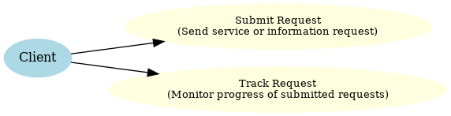
Figure 3.3 (Client)

3.3. Client
ID | UC003
Name | Submit Request
Description | Client can submit a service or product request.
Requirement(s) | FR002
Actor(s) | client
Precondition | Client must have an active account.
Post condition | Request is logged in the system for further processing.
Basic Flow | Basic Flow  - Client navigates to the request submission page.  - Client fills out the following details:  - Request type (e.g., service, product).  - Detailed description.  - Priority level.  3. System validates the request data.  4. Request is successfully logged in the system.  Alternative Flow  1. Client attaches additional documents to the request.  2. System accepts and logs the documents along with the request.  Exceptions  - Request type is invalid.  - System fails to save the request.

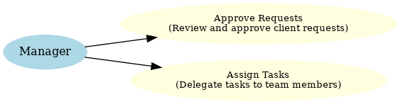
Figure 3.4 (Manager)

3.4. Manager
ID | UC004
Name | Assign Tasks
Description | The Manager assigns tasks to staff members
Requirement(s) | FR004
Actor(s) | Manager
Precondition | Task templates must exist in the system.
Post condition | Tasks are assigned successfully.
Basic Flow | Basic Flow  - Manager selects a team member from the list.  - Manager assigns a task:  - Select task type.  - Set a deadline.  - Add additional instructions (if required).  3. System notifies the assigned team member.  Alternative Flow  - Manager assigns tasks in bulk using a batch process.  - System processes and updates all assignments simultaneously.  .  Exceptions  - Team member is unavailable for assignment.  - Task deadline is set to an invalid date.

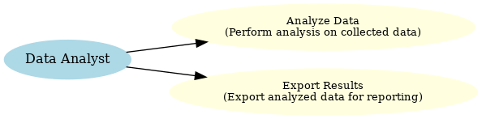
Figure 3.5 (Data Analyst)
  - Data Analyst
ID | UC005
Name | Analyze Data
Description | The Data Analyst reviews and analyzes collected data for reporting purposes.
Requirement(s) | FR005
Actor(s) | Analyst
Precondition | Data must be available in the system.
Post condition | Analyzed results are saved or exported.
Basic Flow | Basic Flow  - Analyst selects a dataset from the dashboard.  - Analyst applies filters or analysis tools:  - Select date range.  - Choose analysis type (e.g., trends, averages).  - Apply additional parameters if needed.  Alternative Flow  - Analyst exports the raw data for offline processing.  - Results are saved as a PDF or Excel file.  .  Exceptions  - Dataset is incomplete or missing.  - System fails to process the data due to an error.

4. References
[1] J. Smith and K. Brown, "Personalized Recommendation Systems: Current Trends and Challenges," 2023.
[2] P. Johnson et al., "AI-Driven E-Commerce Solutions: A Survey," 2022.
[3] A. Lee, "Enhancing Online Shopping Experiences with Recommender Systems," 2021.
[4] Amazon Recommendation Engine, accessed 2023. [Online]. Available: https://www.amazon.com
[5] Netflix Recommendation System, accessed 2023. [Online]. Available: https://www.netflix.com
[6] Shopify Product Recommendations, accessed 2023. [Online]. Available: https://www.shopify.com
[7] eBay Personalized Search and Recommendations, accessed 2023. [Online]. Available: https://www.ebay.com

